PACK UR BAGS (Group - 17)

**Pack UR Bags** is a travel website that offers a wide range of travel destinations and experiences to its users. The website provides a simple and easy-to-use platform for users to plan and book their dream vacations. The website's interface is designed to make navigation seamless and convenient for users.

The main page of the website contains a navbar with icons for Gallery, Places, About, Services, and Reviews. The Gallery showcases a few select places and destinations, while the Places section offers eight different types of travel experiences - beach, islands, hill station, forest, winter, cultural, desert, and country site. Users can select their preferred type of travel experience and view all available destinations in that category.

The About section provides information about the website, while the Services section displays the various services offered by **Pack UR Bags**. The Reviews section features feedback and ratings from previous customers. Users can also leave their feedback on the bottom of the page.

In the Places section, users can select a specific travel destination and view more information about it. If they decide to book a trip, they can do so by filling out their details and making payment through the website. The website also provides users with a profile section where they can edit their personal information and view their saved tours in the "My Tours" section. In the "Transactions" page, users can view their billing details.

**Pack UR Bags** is a comprehensive and user-friendly travel website that offers an easy and efficient way to plan and book vacations. With its wide range of travel destinations and services, **Pack UR Bags** is the perfect choice for anyone looking to escape from the daily routine and explore new places.

1. Bounded Contexts:

* User Management Bounded Context: This context handles the creation and management of user accounts, as well as authentication and authorization.
* Destination Management Bounded Context: This context handles the management of travel destinations, including their descriptions, images, and availability.
* Booking Management Bounded Context: This context handles the management of bookings, including the selection of destinations, the calculation of prices, and payment processing.
* Feedback Management Bounded Context: This context handles the management of user feedback, including the submission and display of feedback.

1. Context Mappings:

* User Management Bounded Context maps to Destination Management Bounded Context to provide user authentication and authorization for booking destinations.
* Destination Management Bounded Context maps to Booking Management Bounded Context to provide destination information for booking.
* Booking Management Bounded Context maps to User Management Bounded Context to associate bookings with specific users.
* Feedback Management Bounded Context maps to Destination Management Bounded Context to associate feedback with specific destinations.

1. Entities, Value Objects, and Services:

* User Management Bounded Context:

1. Entity: User
2. Value Object: User Information (name, email, password)
3. Service: User Management Service (create user, authenticate user, authorize user)

* Destination Management Bounded Context:

1. Entity: Destination
2. Value Object: Destination Information (name, description, image, availability)
3. Service: Destination Management Service (create destination, update destination, delete destination)

* Booking Management Bounded Context:

1. Entity: Booking
2. Value Object: Booking Information (destination, number of travellers, total price)
3. Service: Booking Management Service (create booking, calculate price, process payment)

* Feedback Management Bounded Context:

1. Entity: Feedback
2. Value Object: Feedback Information (destination, rating, comment)
3. Service: Feedback Management Service (create feedback, display feedback)
4. Cardinality Ratios:

* One User can have many Bookings (1: n)
* A booking can have only one customer, but a customer can have multiple bookings.
* A booking can have multiple payments, but a payment can be associated with only one booking.
* One Destination can have many Bookings (1: n)
* One Destination can have many Feedback (1: n)

1. Aggregates:

* User Aggregate: User, User Information, Reviews.
* Destination Aggregate: Destination, Destination Information, Reviews.
* Booking Aggregate: Booking, Booking Information, Destination, User
* Feedback Aggregate: Feedback, Feedback Information, Destination, User.

Basic Use Case Diagram:

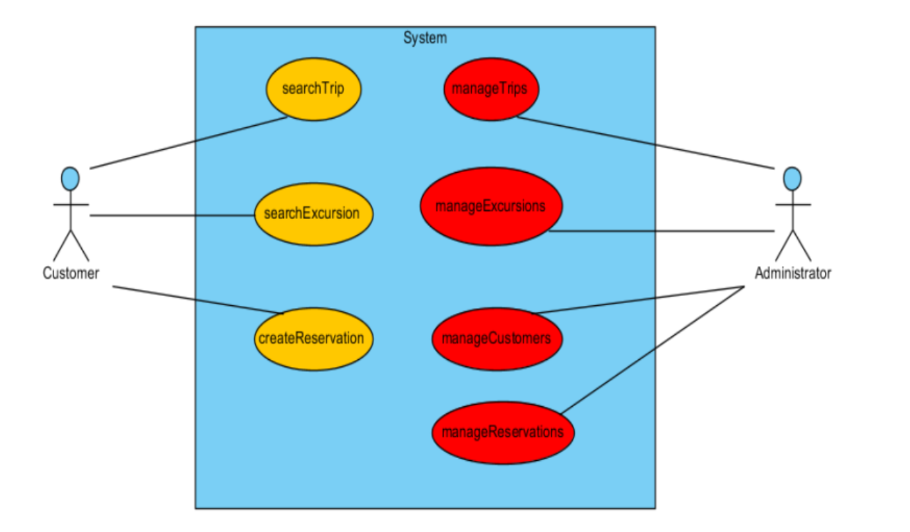

Use Case Model:

